Dear Chamber Choir Students and Families,
Welcome to our NEW fundraiser – Choir Trip Sponsor T-shirts and Advertising - that has been designed to support the 2018-19 Trip to NYC. Please read this packet carefully so that you understand the procedures and meet our deadlines. Sponsorship provides an opportunity for area businesses and patrons to show their support for Music Travel Education and the HHSC program. In return for Sponsors’ generous support, HHSC will provide several advertising opportunities during the 2018-2019 choir season.
Please begin contacting potential sponsors immediately. Time is Short!
All Sponsor logos and donations should be turned in by Monday, November 5th, 2018 for the December Concert Programs and for T-shirts to be ready to wear when we return from Winter Break.
We are asking every Chamber Choir student to call on/mail sponsorship requests to at least 5-10 Hudson/Cleveland/Akron area companies/business. When you have mailed or contacted the business you must log that onto the Google Classroom Sponsorship Campaign Spreadsheet so that businesses only receive contact from one student/family.
You may make as many copies of the forms as you need to give to potential sponsors. There are PDF copies on Google Classroom. Use the enclosed blank letterhead to write a personal note to potential sponsors. You may also personally collect forms, checks and digital logos (AI, EPS, or PDF files) from sponsors instead of them mailing them in.
All checks should be made out to HUDSON HIGH SCHOOL MUSIC ASSOCIATION – CHOIR, PO Box 254, Hudson, OH 44236.
Digital logo graphics (AI, EPS, or PDF files) can be sent to ChoirVP.hhsma@gmail.com
Please let us know if you need support with a potential sponsor and you may direct questions you can not answer to Mrs. Cox, Mrs. Sullivan at ChoirVP.hhsma@gmail.com or Mr. Moore at moorej@hudson.k12.oh.us
Thank you,
Sharlene Cox & Mary Sullivan
CO-VPs Choir, HHSMA

TIPS FOR SELLING SPONSORSHIPS
- Use the blank page that follows to type or handwrite a note to the potential sponsor. Try to address it to a specific person. If this is someone you know from your neighborhood, church or other organization or business remind them who you are and why this trip is meaningful to you. Make it personal.

- Remind sponsors that this is a tax-deductible donation. HUDSON HS MUSIC ASSOC. IS A 501 (c)(3) NONPROFIT ORGANIZATION.

- Follow up on the letters sent with a phone call and finish the arrangement with a thank you note.

- Reach out to companies outside of the small business sector in Hudson who maybe struggling after a long period of downtown construction. Approach music stores, schools, drycleaners, and others who have and will continue to benefit from a strong and growing Hudson Choir program. Reach out to out-of-state organizations that you may have a relationship with.

- All checks should be made out to HUDSON HIGH SCHOOL MUSIC ASSOCIATION – CHOIR, PO Box 254, Hudson, OH 44236. Digital logo graphics (AI, EPS, or PDF files) can be sent to ChoirVP.hhsma@gmail.com

- Please let us know if you need help with a potential sponsor and you may direct questions you can not answer to Mrs. Cox or Mrs. Sullivan at ChoirVP.hhsma@gmail.com or Mr. Moore at moorej@hudson.k12.oh.us

- When you know you have a sponsor arranged, indicate that on the Spreadsheet. If there is going to be a delay in receiving money or the logo, please contact Mrs. Cox/Mrs. Sullivan so we can appraise the situation. If a company would prefer to write us the check in January for tax reasons, we need to know that and can work with them.

- Have fun with this! You will need to reach out to companies and individuals for help and support all your life. Confidence in selling yourself and a program that you believe in is a tremendous skill to have. Good luck!

- Please begin contacting potential sponsors immediately by mail, phone and in-person and log it on the Google Classroom Sponsorship Campaign Spreadsheet.

September 25, 2018

Dear Friends of the Hudson High School Choral Program,
Northeast Ohio communities have a strong history of supporting Music Education and we would like to reach out to Northeast Ohio businesses and companies through our 2018-2019 Choir Trip Sponsorship Campaign.
The Hudson High School Choral program has enjoyed enormous growth in the last 4 years and is touching more young lives than ever before. Music Performances have long been regarded as a powerful educational tool for young musicians to interact and share music with similar musicians and audiences from many cultures. I have selected one domestic destinations for these young artists from Hudson to experience world culture, world class performance spaces alongside their fellow musicians in 2019. The Chamber Choir (advanced group) will spend 4 days in May in New York City to tour and participate in performances to be given at St. John the Divine and St. Paul the Apostle. It has been seven years since HHS Chamber Choir has traveled on their own and performed in the major cities that we have in this beautiful country and these students have been working very hard for this long anticipated opportunity.
Your generous sponsorship helps reduce the cost to educate these young adults in a once-in-a-lifetime opportunity to hear and perform the world's greatest classical music in world class cities. Families have invested their time in lessons for as many as four years for one or more children per family. Your sponsorship can make a lasting impact on a student's ability to participate in this unique opportunity.
As a HHSC sponsor, you will receive sponsor recognition at each performance throughout our concert season including my personal endorsement to patronize your business or product. We distribute over 3000 programs throughout the year to choir families, friends and community members. We will also be designing a NYC Trip shirt that will include your logo as a sponsor. Please see the next page, for the outline of the back of shirts on which your logo will be proudly worn.
Please consider supporting the Hudson Chamber Choir Trip. Your tax deductible sponsorship can be made to the Hudson High School Music Association, a 501(c)(3) non-profit organization. I hope that we can work together to make possible a dream for students to perform in the World's leading concert venues, experience world culture and create life-long memories while performing with one another
Sincerely,
Jacob A Moore, Director of Choral Activities

Choir T-Shirt & Advertising Sponsorship Fundraiser
Chamber Choir’s 2019 NYC Trip

I would like to be a Sponsor ________________________________________________________________________

______ MAESTRO Sponsor $2,000 or top donation
______ CHOIR MASTER Sponsor $500
______ SECTION LEADER Sponsor $200
______ Concert Program listing only $100

Business Contact Info
Name_________________________________________
Address_______________________________________
Phone________________________________________
Contact_______________________________________
Email________________________________________

Complimentary T-Shirt size for Maestro & Choir Master Sponsors (circle one) 2XL XL L M S
-----------------------------------------------------------------------------------------------------------------------------------------------------------
RECEIPT: HUDSON HS MUSIC ASSOC. IS A 501 (c)(3) NONPROFIT ORGANIZATION.
T-SHIRT & ADVERTISING SPONSORSHIP FUNDRAISER
Business:________________________________________________________
Donation: $_______________ on the Date:___________________________
To Sponsor the Hudson High School Chamber Choir 2019 Trip to New York City
THANK YOU FOR YOUR SUPPORT!
Please send Digital logo graphics (AI, EPS, or PDF files) logo to: choirvp.hhsma@gmail.com
Please send this form and check payable to HHSMA to PO Box 254 Hudson, OH 44236

If you have any questions, please contact Sharlene Cox or Mary Sullivan, choirvp.hhsma@gmail.com
SPONSORSHIP PROGRAM LEVELS AND DETAILS

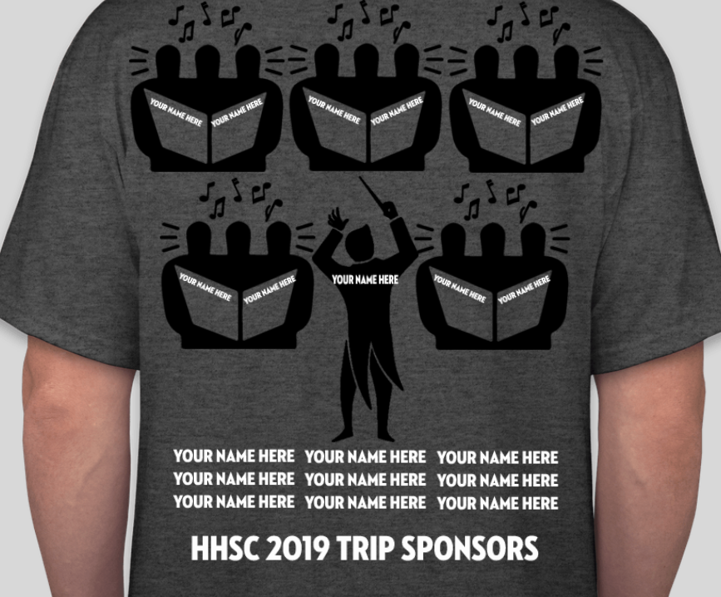
MAESTRO Sponsor: $2,ooo or top donation
Includes logo on conductor on trip t-shirt + 3 concert programs & website sponsor list.

CHOIR MASTER Sponsor: $500
Includes logo on one of 9 inner circle instrumental chairs on trip t-shirt + 3 concert programs & website sponsor list.

SECTION LEADER Sponsor: $200
Includes your name or business name one line on trip t-shirts + 3 concert programs & website sponsor list.

Concert Program listing only: $100:
Includes your name or business name on one line of 3 concert programs & website sponsor list.

Please come see our choirs in action! Admission is always FREE, Experience PRICELESS!

2018-19 HHS CHOIR PERFORMANCE SCHEDULE
(If anyone in your party needs assistance or special seating, please email us in advance, choirvp.hhsma@gmail.com)

Fall Concert: Thursday, October 18, 2018 at 7 pm in the Hudson High School Auditorium
Winter Concert: Wednesday, December 12, 2018 at 7 pm in the Hudson High School Auditorium
Mid-Winter Concert: Wednesday, February 27, 2017 at 7 pm in the Hudson High School Auditorium
Spring Awards Concert: Wednesday May 8, 2017 at 7 pm in the Hudson High School Auditorium

